**UGANDA MARTYRS UNIVERSITY STUDENT REGISTRATION SYSTEM**

**BY NABAKIIBI SYLVIA**

**2021-D012-12066**

**SYLVIA.NABAKIIBI@STUD.UMU.AC.UG**

**SYSTEM REPORT**

**Table of Contents**

**1. Introduction**

**2. System Requirements**

**3. Design and Implementation**

* **Main Menu Form**
* **Student Registration Form**
* **Course Enrollment Form**

**4. Additional Features**

**5. Testing and Validation**

**6. Conclusion**

**1. INTRODUCTION**

The University Registration and Management System is designed to streamline the process of student registration, course enrolment, and timetable management. Implemented using Visual Basic, the system simulates a simplified university registration process, allowing students to register, enroll in courses, and manage their schedules through an intuitive graphical user interface (GUI).

**2. SYSTEM REQUIREMENTS**

**Hardware Requirements**

* A computer with Windows operating system.
* At least 4GB of RAM.
* Sufficient disk space for Visual Studio and the project files.

**Software Requirements**

* Visual Studio with Visual Basic support.
* .NET Framework.

**3. DESIGN AND IMPLEMENTATION**

The system consists of three primary forms: the Main Menu Form, the Student Registration Form, and the Course Enrollment Form. Each form serves a specific function within the system and includes various features to ensure proper data handling and user interaction.

* **Main Menu Form**

The Main Menu Form acts as the entry point of the application. It provides buttons for navigating to the Student Registration Form and the Course Enrollment Form, as well as a logout button.

**Features**

- Navigation to Registration and Enrollment forms.

- Display of students details.

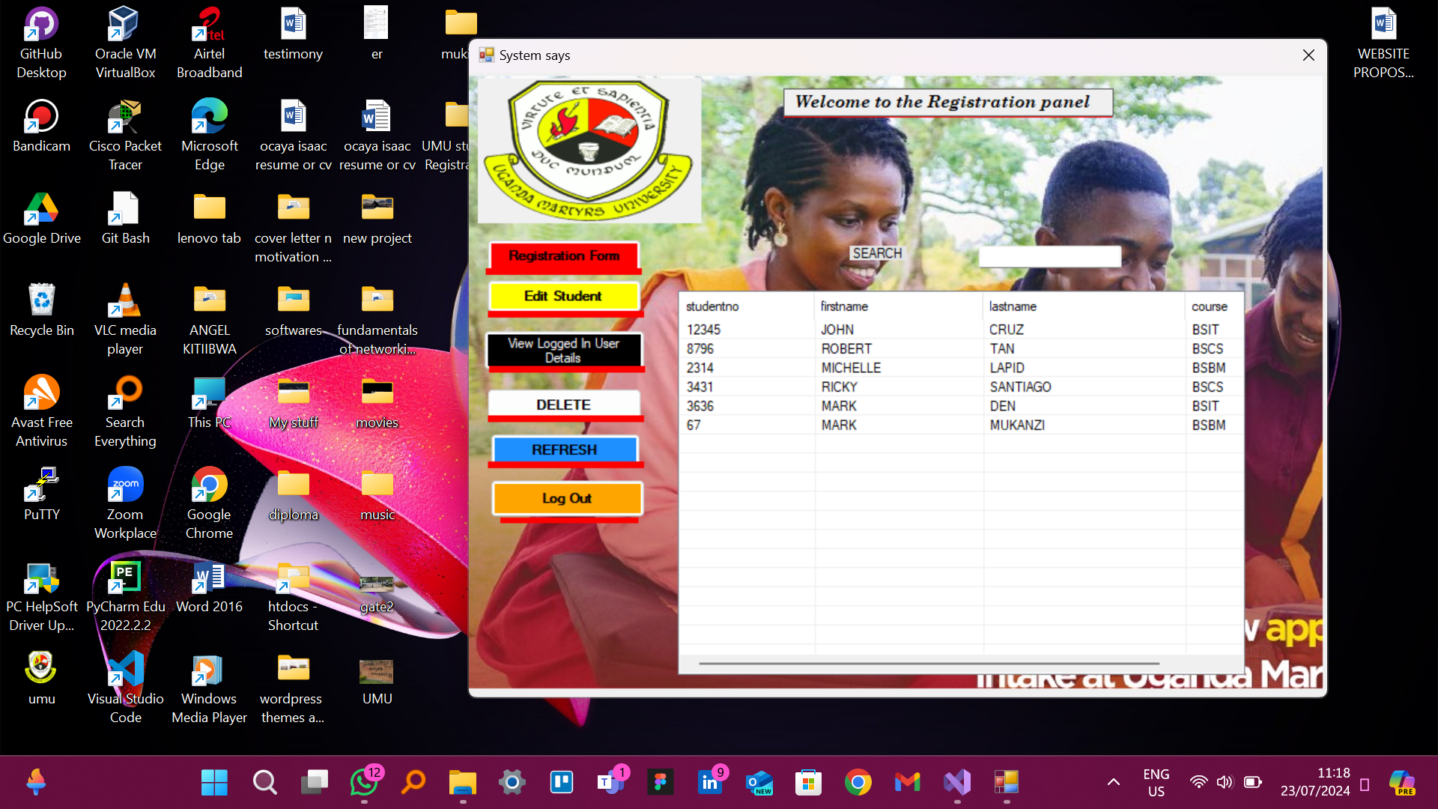

* **Student Registration Form**

The Student Registration Form allows the entry of new student information. It includes fields such as Student ID, First Name, Last Name, Date of Birth, Email, Phone Number, Address, and Program of Study. The form validates input fields to ensure completeness before submission.

**Features**

- Entry and validation of student data.

- Saving student information to a file.

- Confirmation message upon successful registration.

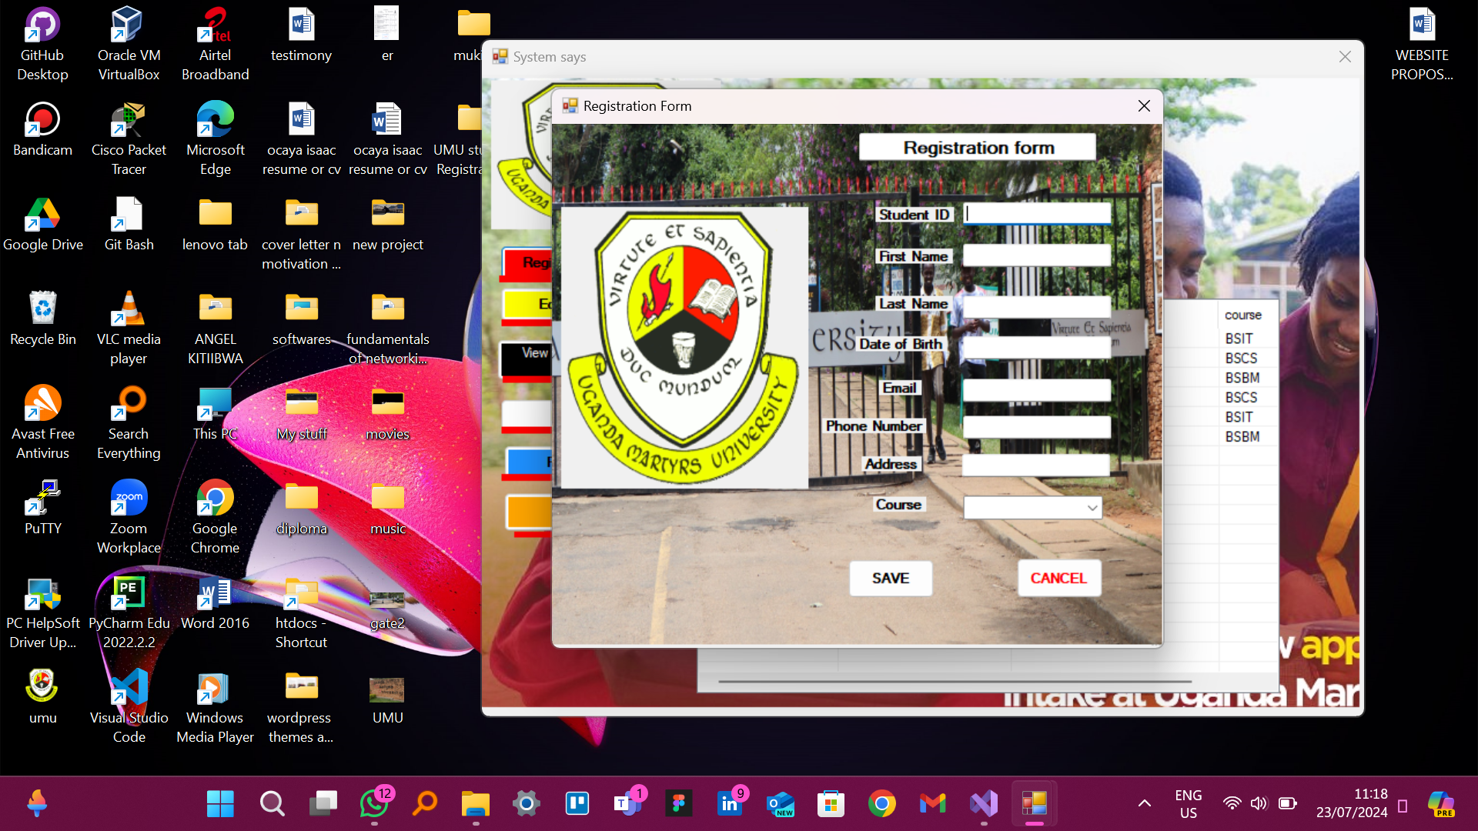

* **Course Enrollment Form**

The Course Enrollment Form enables registered students to enroll in courses. It displays a list of available courses with checkboxes for selection and includes a field to identify the student enrolling in the courses.

**Features**

- Selection of courses using checkboxes.

- Validation of Student ID.

- Saving enrollment data to a file.

- Confirmation message upon successful enrollment.

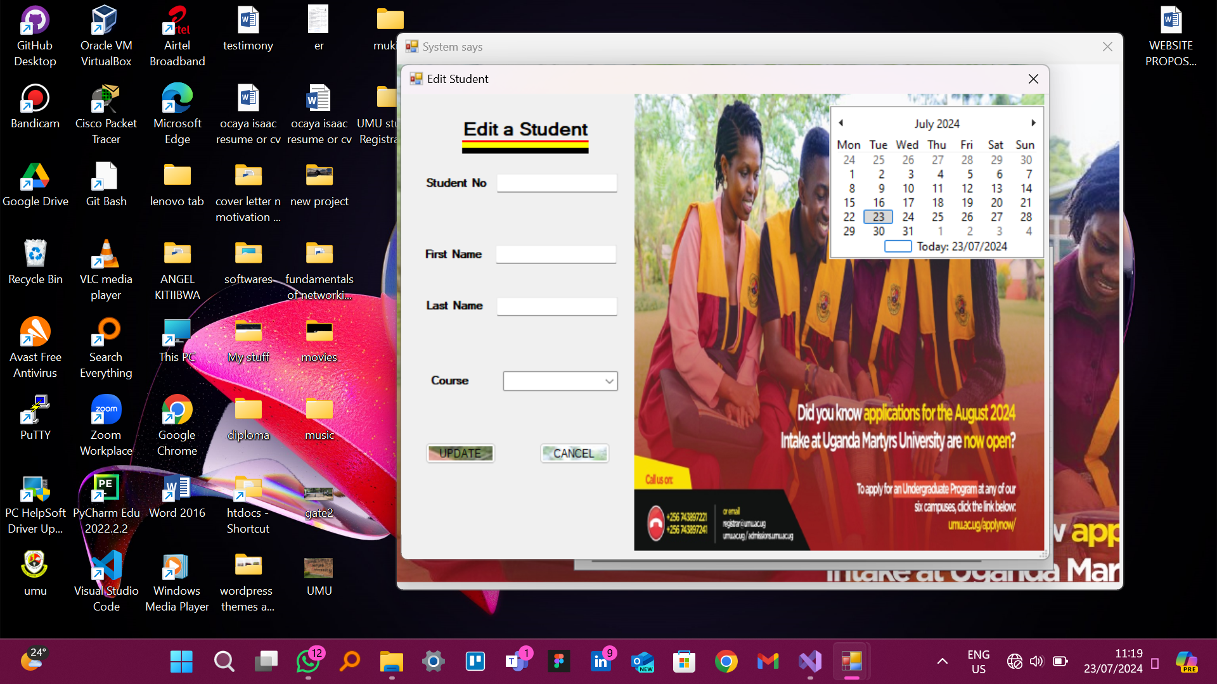

**4. ADDITIONAL FEATURES**

The system can be extended to include additional features such as:

* **Login System**

Implementing a login system with different roles (e.g., student, admin).

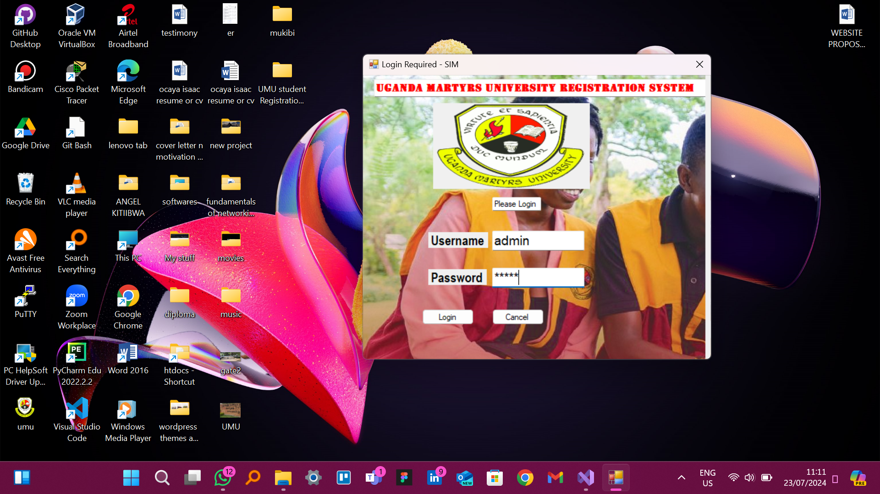

**Database Integration**

Using a database for storing and retrieving student and course information.

**5. Testing and Validation**

The system was tested to ensure the correct functioning of each form and feature. This includes:

- Ensuring all fields are validated correctly.

- Checking the navigation between forms.

- Verifying that data is saved and retrieved accurately.

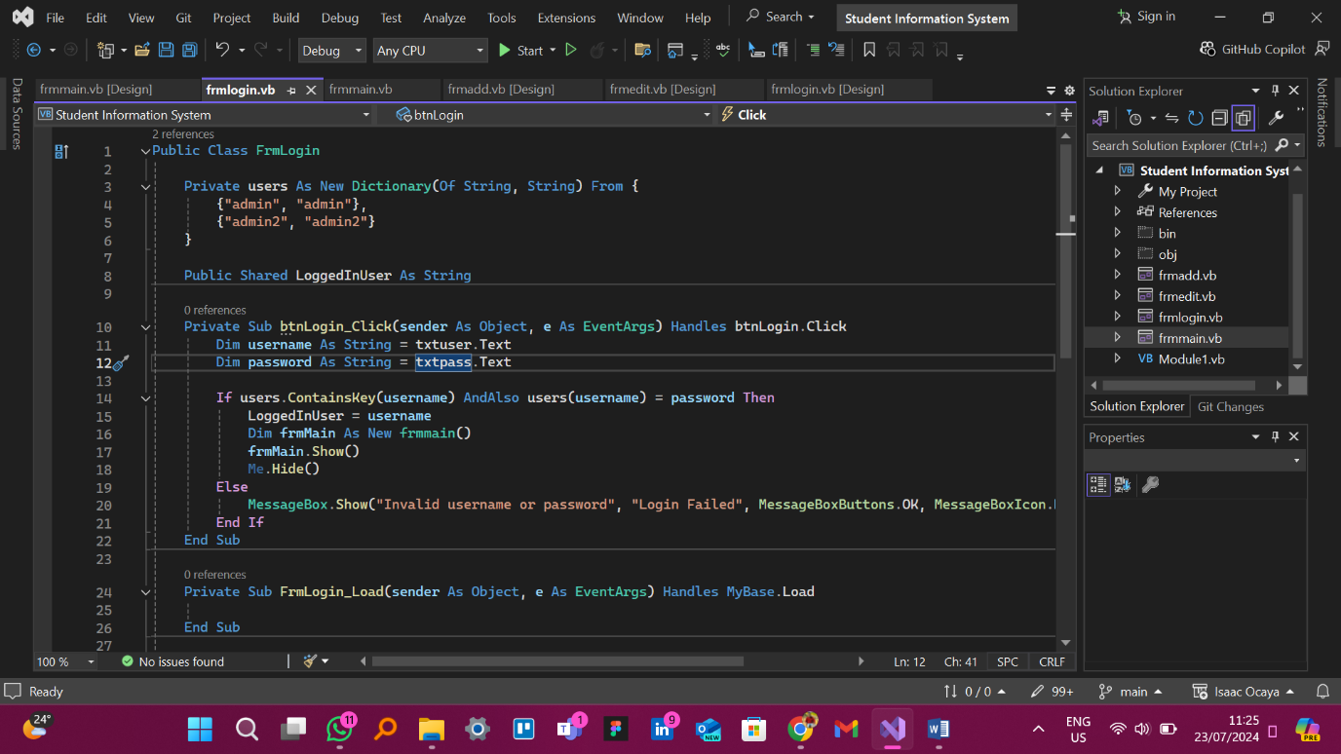

**6. CONCLUSION**

The Uganda Martyrs University Student Registration and Management System provides a functional framework for managing student registration and course enrollment processes. While the current implementation uses text files for data storage, it can be extended to include more advanced features and integrations to enhance its functionality and usability.